Computer Database – Automation Framework

Description and how to run tests

# Index

1. Specifications
2. Pre Requisites
3. Framework
4. How to Run Test
5. Technical Challenges

**Specifications-**

|  |  |
| --- | --- |
| Language Used | Java |
| Eclipse used | Luna |
| Selenium | 2.39 |
| Reporting | Extent Reports 2.05 |
| Framework | Hybrid Framework |
| JDK | 1.8 |
| POI | 3.0 |
|  |  |

**Pre Requisites –**

1. Java 8 ( JRE 1.8)
2. Jar download not required all the jars are in lib folder
3. TestNG
4. Eclipse Luna
5. Selenium 2.39
6. Extent Reporting 2.05

**Framework –**

The Framework Used for this project is hybrid framework using Page Object model.

The framework is divided into classes for each page modules and test classes which are actual tests.

Excel sheets are used to maintain test data.

Very innovative extent reporting is used for reporting.

**Regression Pack**

Below Scenarios and test were chosen out of entire pack as regression candidates

|  |  |  |  |
| --- | --- | --- | --- |
| Functionality | Scenario Name | Scenario Description | Test Case Name |
| Landing page | SC01_Computer_Database_Landing_Page | Verify the Landing Page of Computer database application | SC01_TC01_Computer_Database_UI |
|  | | | |
| Add New Computer | S02_Add_New_Computer | Verify the Add New Computer Functionality | SC02_TC01_Add_New_Computer_Page_Navigation |
| SC02_TC07_Add new computer_Create |
| SC02_TC08_Add new computer_Cancel |
|  | | | |
| Filter Functionality | SC03_Filter_Functionality | Verify the filer by name functionality | SC03_TC01_Filter_Computer_Name_Alphabets |
| SC03_TC02_Filter_Computer_Name_Numeric |
|  | | | |
| Edit Computer | SC04_Edit_Computer | Verify that the user can edit the computer | SC04_TC01_Edit_Computer_Details |
|  | | | |
| Delete Computer | SC05_Delete_Computer | Verify that user can delete the computer | SC05_TC01_Delete_Computer |
|  |  |  |  |
| Pagination | SC06_Pagination_Functionality | Verify the pagination functionality | SC06_TC01_Pagination_10_Records_Displayed_Next_Previous |
| SC06_TC02_Pagination_No_Of_Records_match |

**Structure of Framework – The structure of framework is as below**

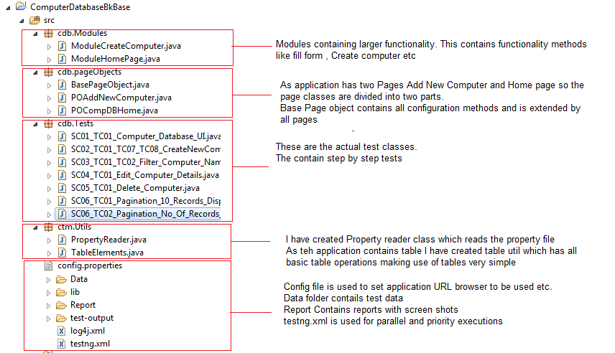

**The framework has following components –**

* **Page Objects** – This is the object repository of all the pages in scope for application under test.

Page objects contains the elements and methods which will perform basic operations on those elements.

As there are two pages under test so we have two page objects, Home Page and Create New Computer Page

* **Base Page Object** – Base page object is a class which has all the methods responsible for initialization of drivers, launching of URL and driver quit.
* **Modules** – Modules extend page objects classes and have bigger functions like create a computer. These methods are then extended by Test classes
* **Tests** – Tests Package contains all the test classes which correspond to regression test case. Some of the test cases are combined in single test class because of similar nature.
* **Utils** – This is a package which contains PropertyReader class which reads the config file. This util package contains TableElements class which performs basic operations on web table. This class accepts table element and perform various operations like returning a particular row column value. This class makes use of web table very simplified.
* **Config File** – is the file which contains various static properties like URL, Browser USED, Data connections and other static properties to be used in future.
* **Lib** – lib is library for all the the jars ( Due to some technical issue was not able to set up Maven)
* **Reports** – a very unique reporting utility is used called extent reports which produces very illustrative reports and attaches screen shot in case of failure. Sample report is below

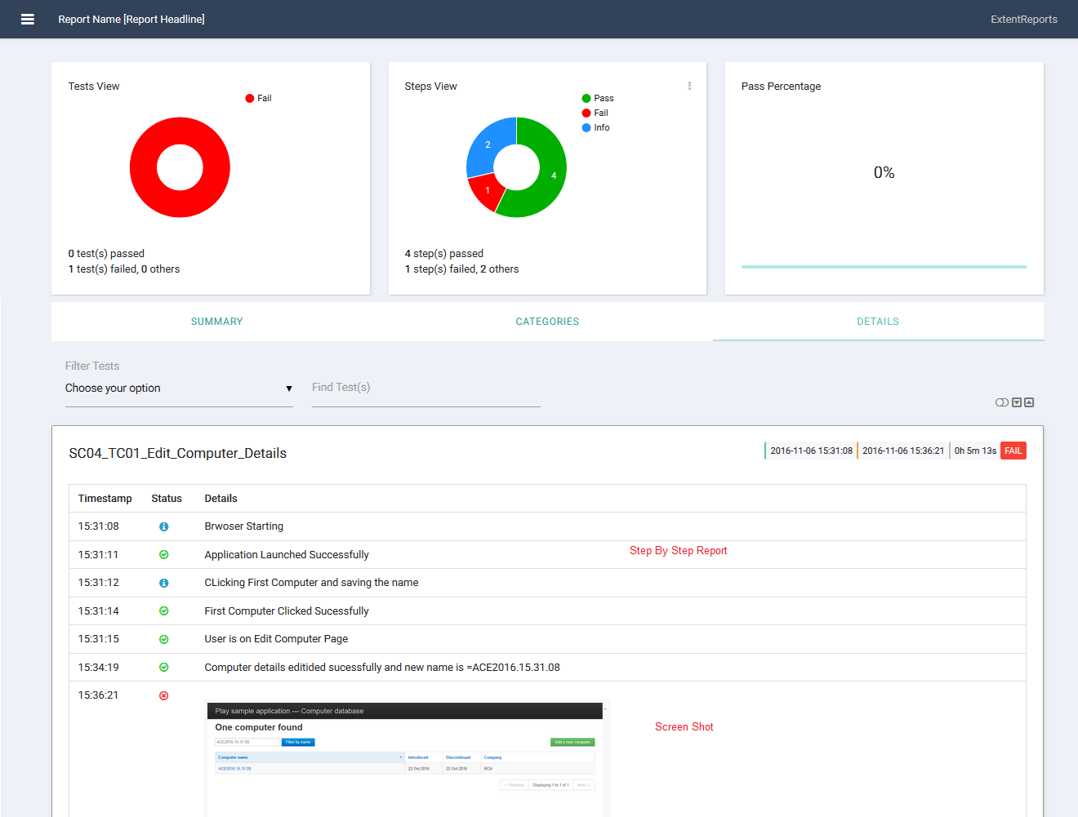

How to run the tests-

There are two ways to run tests

1. Running the tests- Each feature file is capable of running individually, users can run the test class as below

Open test class>click on Run > Go to Run As > Select “Run As TestNG” as shown below

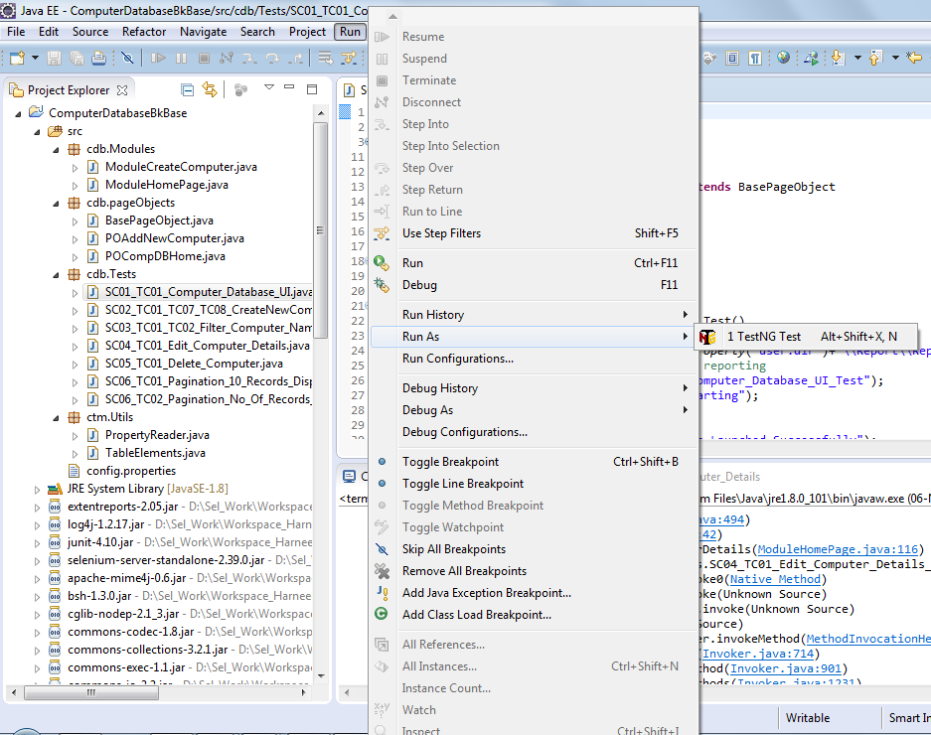

1. Running TestNG xml –

Right Click testing.xml>Go to Run As > Select “Run As TestNG”

**Technical Challenges –**

1. Due to some technical issue set up of Maven was not Possible